SLDD – Sea Lion Deterrent Device

Stand-off Sea Lions from 50 to 200 meters

Specifications:

Input power - 208-240vac, 1Ø, 60 Hz

Stored energy 3kJ 6kJ 12kJ

Distance m 50 100 200 50 100 200 50 100 200
Pressure Psi 4 1 ¼ 8 2 ½ 16 4 1
Line power kva 3 6 9
Duty Cycle
Ave. sec. 5 5 5

Burst sec. 2 2 2
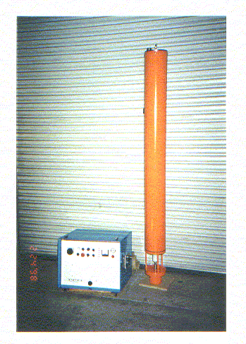
ADVANCED CONVERSION TECHNOLOGIES, INC.
2830A Via Orange Way – Spring Valley, CA 91978 - (619)670-1612

